**Project Design Phase-II**

**Data Flow Diagram & User Stories**

| Date | 15 October 2022 |
| --- | --- |
| Team ID | PNT2022TMID23204 |
| Project Name | Project - Real-Time River Water Quality Monitoring and Control System |
| Maximum Marks | 4 Marks |

**DATA FLOW DIAGRAM:**

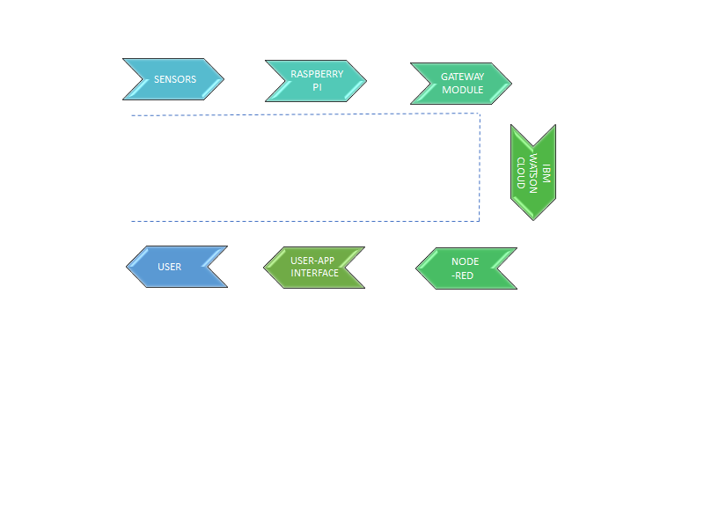

**User Stories**

| **User Type** | **Functional Requirement (Epic)** | **User Story Number** | **User Story / Task** | **Acceptance criteria** | **Priority** | **Release** |
| --- | --- | --- | --- | --- | --- | --- |
| Customer (people) | Monitor the quality of water | USN-1 | As a user, I can monitor the quality of water when the water quality is low I can identify it. | I can maintain the river water with less labor | High | Sprint-1 |
|  | Analyzing Problems | USN-2 | As a user, I collect the required information about the problems on contaminated water | I can ask the government directly. | Low | Sprint-2 |
|  |  | USN-3 | As a user, I can monitor the pH level , temprature and Turbidity of water and solve the problems by using Smart IOT System | I can take remedial action immediately | High | Sprint-1 |
| Project Designers | Identifying the problem and provide solutions | USN-4 | As a user, I can sense the water level using sensor and monitor using IOT | I can perform this actions via IoT. | Medium | Sprint-1 |
|  |  | USN-5 | As a user, I can test the purity of the water | I can solve this problem using IOT | High | Sprint-1 |
|  |  |  | As a user, I can monitor the river water against dumping waste by industries | I can monitor the river water continuously. | Medium | Sprint-2 |
| Customer (people) | Problem solutions | USN-6 | As a user, areas can be monitored from a remote place | Checking Process | Medium | Sprint-3 |
|  | Application | USN-7 | As a user, I can respond to the problems immediately | Continuous monitoring and remedial actions. | Medium | Sprint-3 |
|  | Final Process | USN-8 | This Real-Time River Water Quality Monitoring and Control System is found to be cost-effective and efficient | I can take necessary action if required. | Medium | Sprint-4 |